Machine Learning Gait Analysis

Kartik Kharbanda

Electronics and Communication Engg.

National Institute of Technology, Delhi  
[191220027@nitdelhi.ac.in](mailto:191220027@nitdelhi.ac.in)

New Delhi, India

Dr. Chandra Prakash

Computer Science Engg.  
National Institute of Technology, Delhi

[cp@nitdelhi.ac.in](mailto:cp@nitdelhi.ac.in)

New Delhi, India

**Abstract:-** Freezing of Gait (FoG) is a common abnormal gait pattern observed mostly in patients suffering from Parkinson’s Disease (PD).In this ailment, patients feel an abrupt inability to practice any locomotion for a brief period of time. Several approaches have been made to detect and prevent the onset of this ailment, none of which are ideal. In this paper, we attempt to make a contribution to society using Feature Learning techniques. We use supervised learning techniques to utilise the time and statistical features to perform detection and classification tasks. We analyze the data for FoG prediction as well and reach the conclusion that this FoG prediction is highly patient dependent, reaching an F1 - score of about 80% for one of the patients. We also present a combined analysis of all the patients which may aid in designing wearable sensors for detection. This system detects FoG with a precision value of about 81%.

**Introduction**

Freezing of gait is one of the most disturbing repercussions of Parkinson’s Disease.According to a survey of 6620 PD patients, 47% of the subjects reported regular freezing and 28% experienced FoG daily. Most of the research works focus on detection, while we take a step forward and focus on classification as well. We make it a three class problem:-  
1. Walk  
2. PreFoG

3. FoG

Making it a 3 - class problem enhances the complexity of the task but predicting the onset of FoG before it occurs is an important task to aid patients.

FoG detection is a two class problem (Walk and FoG Class) and we aim to use several machine learning models to tackle this classification problem.

**Dataset**

The dataset used for the experiment is the publicly available DaphNet dataset. It contains records of 10 idiopathic PD patients (7 males, 3 females, 66.5 +- 4.8 years).

In the experiment, 3 motion sensors were attached to the body of the patient. The first sensor was attached to the ankle, the second one was attached to the thigh while the last sensor was attached to the torso of the patient.

Each patient had to perform three basic tasks:

1. Walk in a straight line including several back and forth 180-degrees turns.
2. Random walking in a free space including several 360-degree turns,
3. Imitating the walking patterns of a normal human and simulating daily walking patterns.

The results obtained from the DaphNet experiment are as follows:

1. Eight of the ten patients exhibited FoG conditions while the remaining two patients did not.
2. The dataset contains a video recording of about 8h 20min consisting of about 237 FoG episodes which were detected by the recording device.
3. The length of FoG episodes ranged from 0.5 to 40.5s (mean 7.3 s [S.D. 6.7s]).
4. 50% of the FoG episodes lasted less than 5.4s and majority of them were less than 20s long.

**Feature Selection**

For the purpose of our experiment, we extract several features from the dataset. These features are statistically significant and some of them can also be retrieved from the sensor.

The features used are mentioned below:

|  |  |  |
| --- | --- | --- |
| **Feature Type** | **Feature** | **Description** |
| Time | Mean | Average value of the signal. |
| Time | Standard Deviation | It is a measure of how much the signal fluctuates/varies from the mean. |
| Time | Variance | It is the squared value of standard deviation. |
| Time | Root Mean Square | The square root of the arithmetic mean of the square values of the signal. |
| Time | Minimum | The minimum value of the signal |
| Sensor | Entropy | Measure of the spectral power distribution of the signal. |
| Sensor | Energy | The sum total energy of the signal |
| Sensor | Peak Frequency | Frequency of the greatest amplitude of the system. |
| Sensor | Freezing Index | Ratio between the power contained in the freezing and locomotion frequency bands. (3-8Hz and 0.5-3Hz respectively) |
| Sensor | Power | Sum of the absolute squares of the values of the signal divided by the signal length. |

**Experiments and Evaluations**

We have performed several sets of experiments using the DAPHNet dataset described previously. Firstly, we present an individual patient analysis for a 3 class problem ( Walk , PreFoG, FoG) in which we show how FoG prediction is highly patient dependent. For this prediction task, we use Decision Trees as our base model for performing our experiment. Next, we perform an overall FoG detection task ( Walk and FoG class) which helps us deduce when Freezing of Gait. For FoG detention problem, we have used several models which are as follows:

1. Decision Trees
2. Random Forest
3. Support Vector Machines (SVM)
4. K Nearest Neighbors (KNN)
5. Ada Boost Classifier

We showcase that SVMs significantly outperform the other machine learning algorithms and display a significant recall value of 96% in gait detection.

For performing each of the above mentioned experiments, we vary the number of features from 5 to 45 with an increment of 5 features each time. Since our evaluations are performed on a patient dependent basis, we observed that the WALK class was highly over-represented in the dataset To overcome this obstacle, we chose to balance our dataset by selecting the size of walk class as n times the size of FoG where, n ∈ {1.5, 2, ..., 10}. For prediction problem, (3 classes) we use Decision Trees (DT) to perform our evaluations while we use 5 models mentioned above for detection (2 classes).

We present our results in terms of F1-scores, recall values for each patients varying with the number of features and try to showcase the ideal number of features to be selected by displaying a mean comparison chart computed through mean of the patients.

**Results**

The top ranked features are:

|  |  |  |  |
| --- | --- | --- | --- |
| **Feature Rank** | **Feature** | **Sensor** | **Axis** |
| 1, 2, 3 | Mean | Ankle | X, Y, Z |
| 4, 5, 6 | Mean | Thigh | X, Y, Z |
| 7, 8, 9 | STD | Ankle | X, Y, Z |
| 10, 11, 12 | STD | Thigh | X, Y, Z |
| 13, 14, 15 | Variance | Ankle | X, Y, Z |
| 16, 17, 18 | Variance | Thigh | X, Y, Z |
| 19, 20, 21 | RMS | Ankle | X, Y, Z |
| 22, 23, 24 | RMS | Thigh | X, Y, Z |
| 25, 26, 27 | Minimum | Ankle | X, Y, Z |
| 28, 29 , 30 | Minimum | Thigh | X, Y, Z |
| 31, 32, 33 | Entropy | Ankle | X, Y, Z |
| 34, 35, 36 | Entropy | Thigh | X, Y, Z |
| 37, 38, 39 | Entropy | Torso | X, Y, Z |
| 40, 41, 42 | Energy | Thigh | X, Y, Z |
| 43, 44, 45 | Energy | Ankle | X, Y, Z |
| 46, 47, 48 | Energy | Torso | X, Y, Z |

**FoG Prediction**

We display our findings for each patient record present in the dataset. The metrics used for evaluation are recall values and F1 - score. We conclude that preFoG detection is highly patient dependent and a maximum F1-score of 83% was observed for one of the patients who displayed enough gait deterioration. The recall values for prediction vary around the 50% mark as we change the different number of features used for evaluation. In one particular case, a recall value of 100% was observed. High F1 score is obtained when the no. of features selected are 15-25.

**F1 Values - WALK Class**

|  |  |  |  |  |  |  |  |  |  |
| --- | --- | --- | --- | --- | --- | --- | --- | --- | --- |
|  | **5** | **10** | **15** | **20** | **25** | **30** | **35** | **40** | **45** |
| **S01R01** | 0.79 | 0.744 | 0.743 | 0.743 | 0.687 | 0.741 | 0.739 | 0.732 | 0.738 |
| **S01R02** | 0.82 | 0.84 | 0.8 | 0.9 | 0.8 | 0.62 | 0.76 | 0.76 | 0.89 |
| **S02R01** | 0.81 | 0.867 | 0.841 | 0.775 | 0.783 | 0.816 | 0.85 | 0.85 | 0.812 |
| **S02R02** | 0.77 | 0.766 | 0.868 | 0.862 | 0.841 | 0.827 | 0.879 | 0.871 | 0.8 |
| **S03R01** | 0.8 | 0.874 | 0.963 | 0.866 | 0.868 | 0.846 | 0.863 | 0.84 | 0.842 |
| **S03R02** | 0.84 | 0.8849 | 0.867 | 0.837 | 0.885 | 0.873 | 0.891 | 0.823 | 0.891 |
| **S05R01** | 0.85 | 0.853 | 0.753 | 0.875 | 0.842 | 0.844 | 0.845 | 0.841 | 0.869 |
| **S05R02** | 0.83 | 0.787 | 0.75 | 0.821 | 0.787 | 0.763 | 0.83 | 0.814 | 0.779 |
| **S06R01** | 0.88 | 0.845 | 0.89 | 0.911 | 0.88 | 0.887 | 0.883 | 0.867 | 0.873 |
| **S07R01** | 0.64 | 0.77 | 0.64 | 0.81 | 0.772 | 0.65 | 0.708 | 0.692 | 0.662 |
| **S07R02** | 0.55 | 0.666 | 0.53 | 0.53 | 0.57 | 0.61 | 0.537 | 0.666 | 0.54 |
| **S08R01** | 0.76 | 0.825 | 0.82 | 0.82 | 0.867 | 0.782 | 0.813 | 0.834 | 0.856 |
| **S09R01** | 0.89 | 0.93 | 0.947 | 0.947 | 0.947 | 0.93 | 0.925 | 0.925 | 0.93 |

**F1 Values - FoG Class**

|  |  |  |  |  |  |  |  |  |  |
| --- | --- | --- | --- | --- | --- | --- | --- | --- | --- |
|  | **5** | **10** | **15** | **20** | **25** | **30** | **35** | **40** | **45** |
| **S01R01** | 0.73 | 0.5 | 0.531 | 0.526 | 0.473 | 0.681 | 0.342 | 0.386 | 0.386 |
| **S01R02** | 3.433 | 0.8 | 0.8 | 0.8 | 0.6 | 0.55 | 0.788 | 0.788 | 0.662 |
| **S02R01** | 0.77 | 0.727 | 0.668 | 0.731 | 0.729 | 0.783 | 0.816 | 0.816 | 0.782 |
| **S02R02** | 0.63 | 0.76 | 0.7 | 0.76 | 0.781 | 0.643 | 0.7 | 0.673 | 0.724 |
| **S03R01** | 0.67 | 0.732 | 0.75 | 0.741 | 0.713 | 0.728 | 0.736 | 0.67 | 0.667 |
| **S03R02** | 0.84 | 0.838 | 0.881 | 0.7 | 0.836 | 0.7 | 0.784 | 0.522 | 0.591 |
| **S05R01** | 0.748 | 0.739 | 0.8 | 0.719 | 0.686 | 0.7 | 0.712 | 0.675 | 0.675 |
| **S05R02** | 0.68 | 0.6 | 0.546 | 0.638 | 0.62 | 0.627 | 0.631 | 0.638 | 0.573 |
| **S06R01** | 0.768 | 0.771 | 0.818 | 0.829 | 0.8 | 0.818 | 0.822 | 0.811 | 0.786 |
| **S07R01** | 0.43 | 0.678 | 0.462 | 0.583 | 0.526 | 0.462 | 0.45 | 0.62 | 0.586 |
| **S07R02** | 0.35 | 0.666 | 0.8 | 0.8 | 0.8 | 0.73 | 0.4 | 0.45 | 0.4 |
| **S08R01** | 0.55 | 0.654 | 0.72 | 0.75 | 0.72 | 0.646 | 0.687 | 0.725 | 0.75 |
| **S09R01** | 0.844 | 0.87 | 0.88 | 0.89 | 0.88 | 0.86 | 0.86 | 0.842 | 0.824 |

**Individual Patient Analysis**

**S01R01**

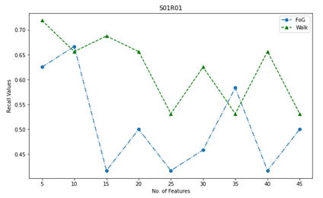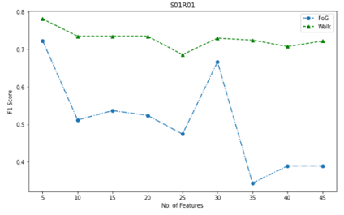

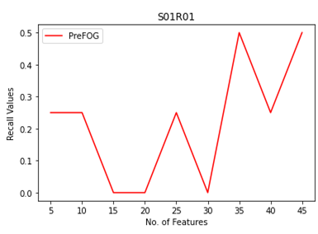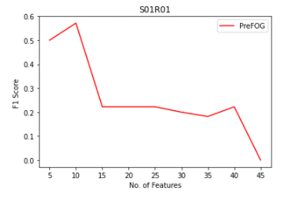

**S01R02**

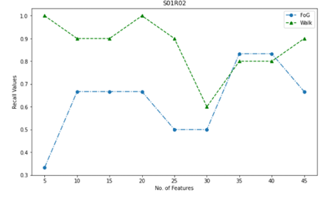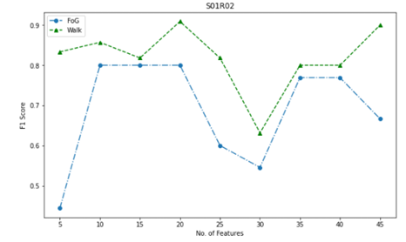

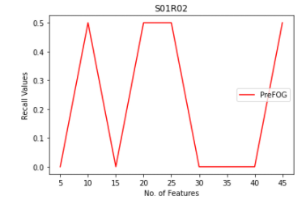 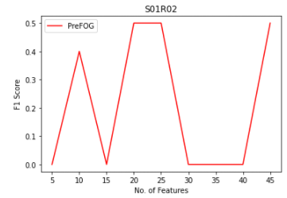

**S02R01**

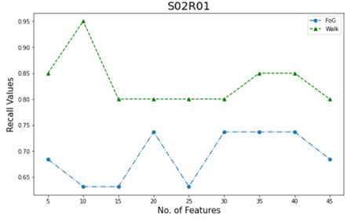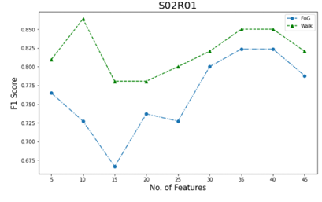

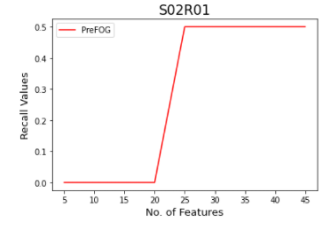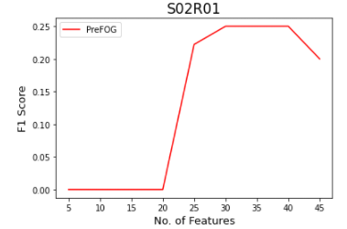

**S02R02**

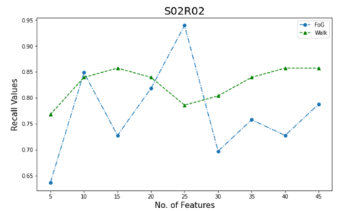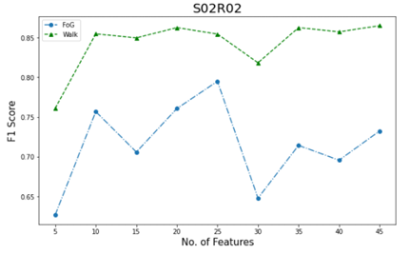

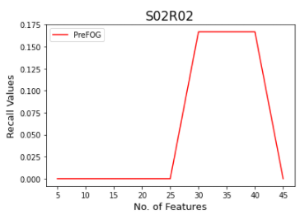 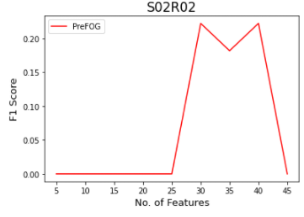

**S03R01**

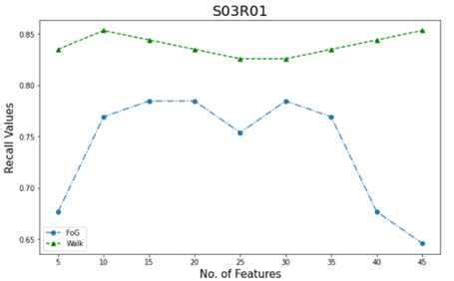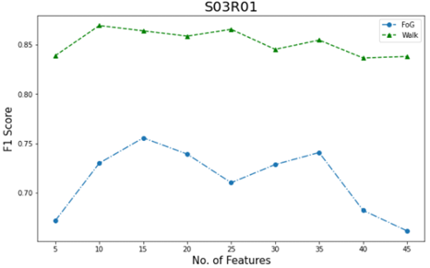

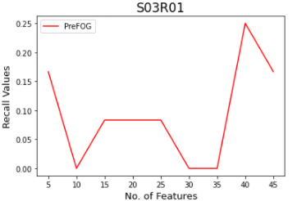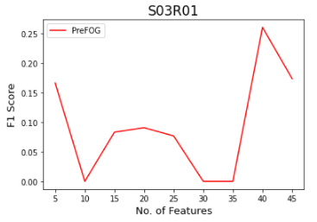

**S03R02**

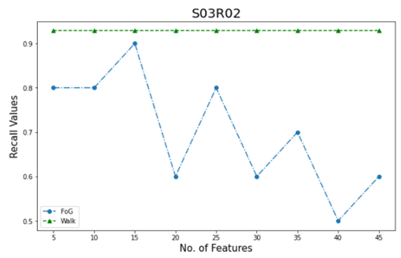 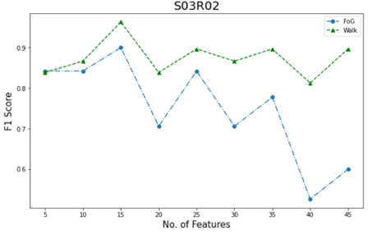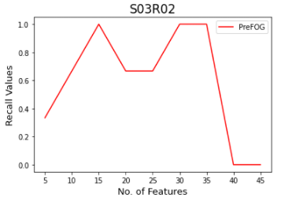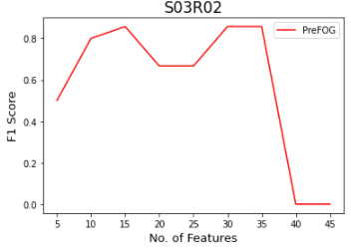

**S05R01**

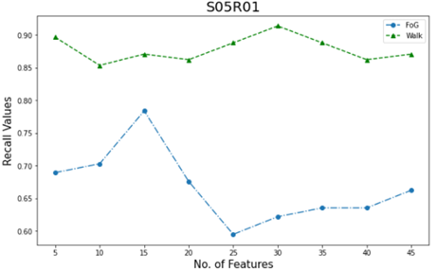 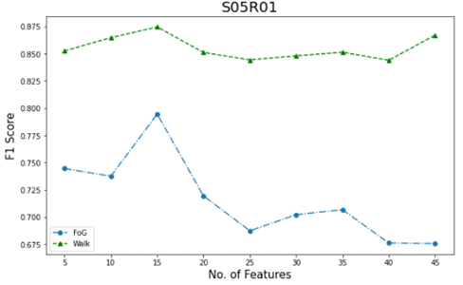

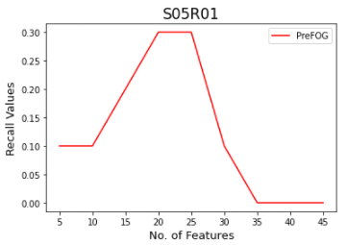 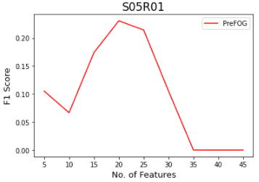

**S05R02**

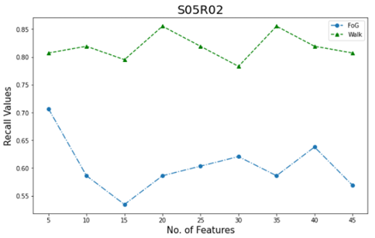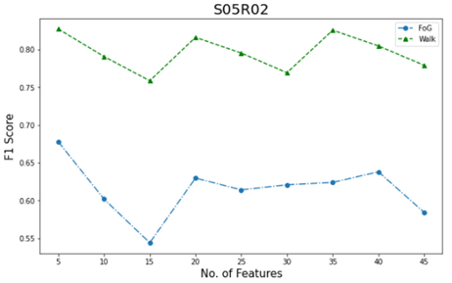

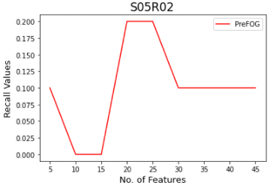 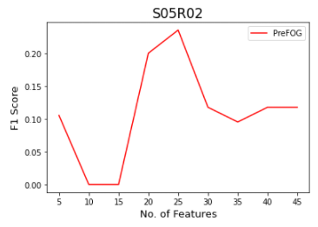

**S06R01**

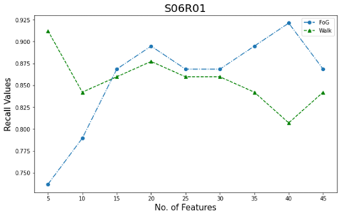 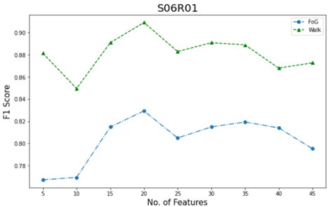

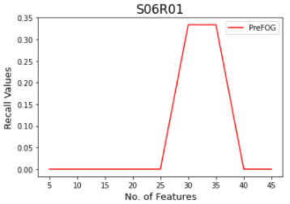 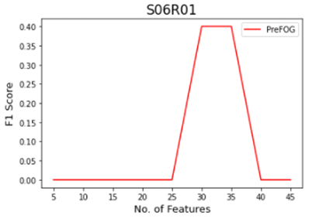

**S07R01**

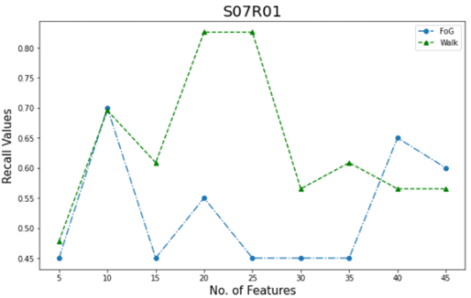 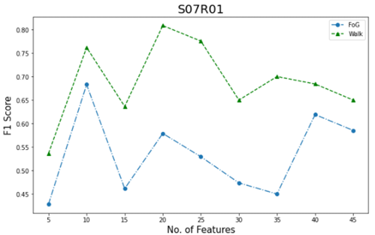

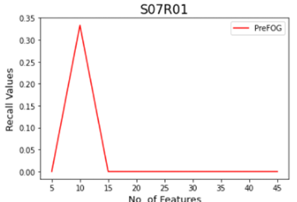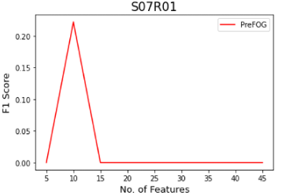

**S07R02**

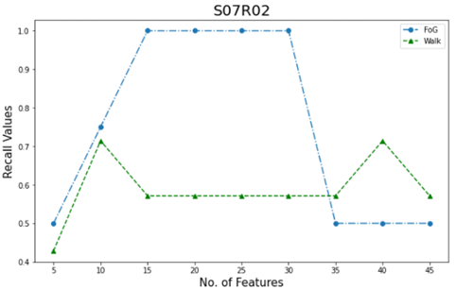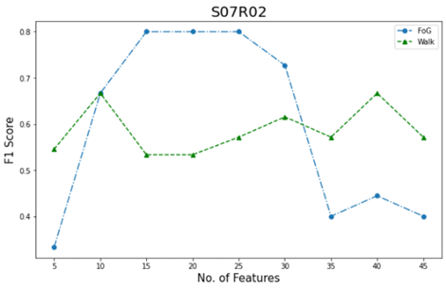

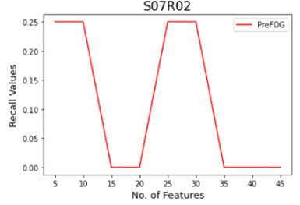 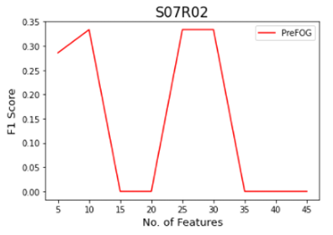

**S08R01**

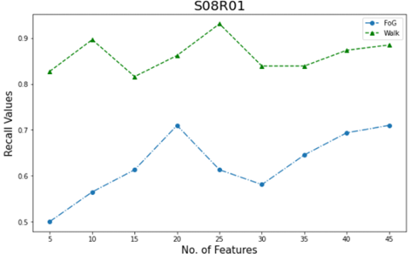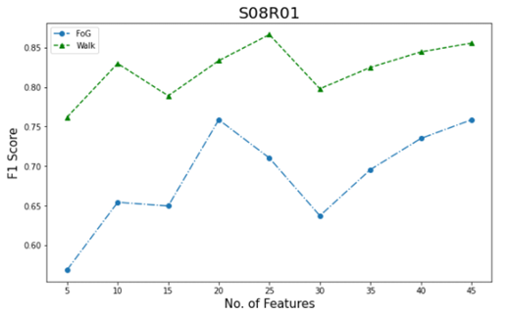

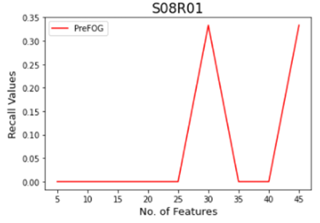 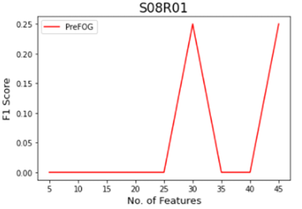

**S09R01**

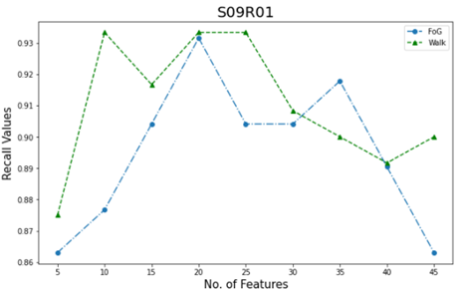 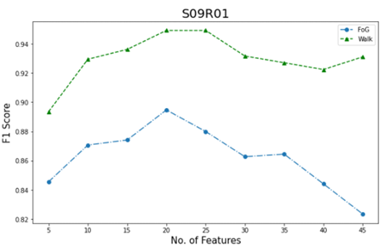

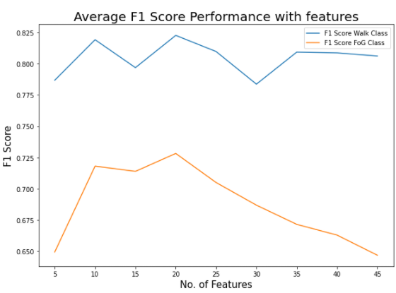

An overall mean comparison showed that the ideal number of features selected for performing Machine Learning techniques are 15 - 25 since high F1 scores for walk and fog class were obtained in this range.

**FoG DETECTION**

For detection, which is a two class problem. We used several machine learning algorithms and concluded that the best algorithms for this classification problem are Random Forests and Support Vector Machines in terms of performance.

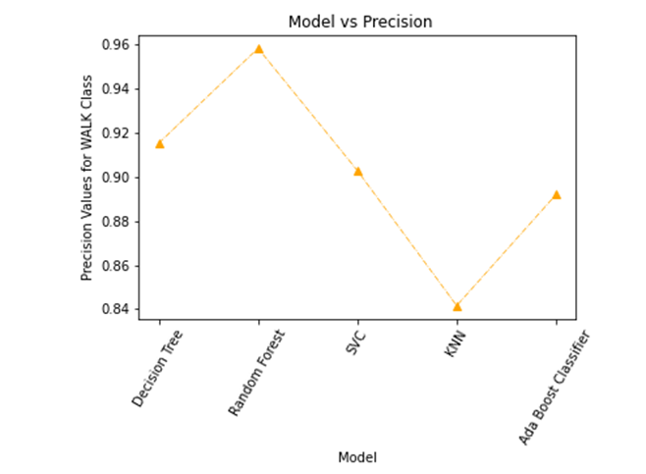 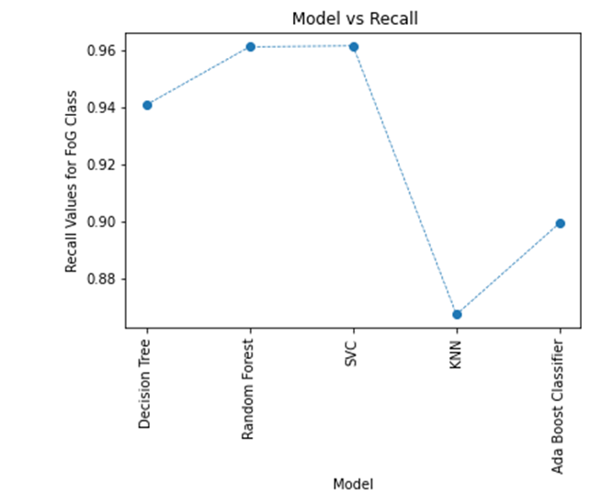

**CONCLUSION**

In this work, we used several feature learning techniques in order to best detect and predict the occurrence of freezing of gait. Several features based on time-domain and even sensor derived features were used. We derived these features from the DaphNet dataset available publicly on UCI Machine Learning repository. Using this dataset, we attempted an individual patient analysis to show that FoG prediction is highly patient dependent and achieved a peak F1 - score of 80%. While performing FoG detection, we observed that SVMs are one of the best algorithms for this task, since they have a smaller model size and a higher accuracy. In the future, we aim to incorporate the use of Neural Network to this work and improve the results obtained. We hope to solve this problem and design small devices with an incorporated ML model which can predict the onset of freezing of gait to help patients in their ailment.

**REFERENCE**

1. Wearable Assistant for Parkinson’s Disease Patients With the Freezing of Gait Symptom   
   Marc Bachlin, Meir Plotnik, Daniel Roggen, Inbal Maidan, Jeffrey M. Hausdorff, Nir Giladi, ¨ and Gerhard Troster ¨ , Senior Member, IEEE.
2. Feature Learning for Detection and Prediction of Freezing of Gait in Parkinson’s Disease  
   Sinziana Mazilu1, Alberto Calatroni1, Eran Gazit2, Daniel Roggen1, Jeffrey M. Hausdorff2, and Gerhard Tr¨oster1.
3. Wearable-Sensor-Based Detection and Prediction of

Freezing of Gait in Parkinson’s Disease: A Review.  
Scott Pardoel , Jonathan Kofman , Julie Nantel and Edward D. Lemaire

1. A Wearable System to Assist Walking of Parkinson´s Disease Patients.